LIBRARY MANAGEMENT SYSTEM 4304

Requirements Specification

* **Functional requirements:**

* Accession number, roll number and teacher identification must all be unique as they form the primary keys of the respective tables.
* All new books must be entered in the accession table first, to avoid problems later.
* A book must not be deleted from student profile unless and until she pays the appropriate fine or the same book.
* While inserting values in the database, only valid values must be entered.
* **Data requirements:**
* The Library Management System shall be required to maintain information about its users and books.
* It shall store databases for students, teachers and books.
* The student database stores information about a student’s roll no, name, address, course and year.
* The book database stores information about a book title, author, publisher, cost, bill number, year of publishing and pages.
* The teacher database stores information about a teacher’s id, name, department, designation, address and telephone number.

* **Software requirements:**
* The system on which the Library Management System is installed must have Microsoft windows in it.
* **Hardware requirements:**
* Genuineintel, x86 Family 15 Model 2 Stepping 4, 120.0 MB RAM.

Services provided to the user

The Library Management System automates the basic library functions to aid in the day-to-day operations of a library. It supports functions such as issue, return, the very basic functions of searching for a particular book, etc.

It also maintains data about books about books, teachers, students records that are required during various library operations. The software aims to make the system user friendly and efficient.

The functions that the Library Management System provides are as follows:

1. INSERT: This operation is performed when new data needs to be added to the system, for e.g. when department purchases a new book, the book’s entry is inserted in the books database. This option has three choices:
2. Book: This choise allows entering data about newly purchased books into the books database. The data entered includes book’s author, title, publisher, cost and various other fields provided in the form. The data must be accurate and must be entered in the correct format as indicated in the forms.
3. Teacher: This option is used for entering data for a new teacher in the teacher’s database. This option is chosen when a teacher joins college.
4. Student: This will enter new record for a student in student’s database. This option is chosen when a student is enrolled in the college.
5. DELETE: This operation clears the existing records in the various databases. It is used when for e.g. a member leaves college or when book is disposed of from library. But care mustbe taken while performing this operation and permissiontaken from the head of library because the system could loose any important data.

It can be performed on all databases and on three choices are:

* 1. Book: This will enter a null value for the book whose accession number is entered in the fieldprovided in the respected form. This operation is done when a book is disposed of the library.
  2. Teacher: This will clear the record for a particular teacher whose identification number is entered. This option is chosen when a teacher leaves college.
  3. Student: This will clear the record for the particular student whose record needs to be deleted by entering her roll number in the required field. This option is chosen when a student leaves college.

1. UPDATE: This function updates data in the various records. This operation is supported by all the three enteries:
   1. Book: This function generally would not be required for updating a book’s status as that data wouldn’t change.
   2. Teacher: This will update the data of particular teacher, whose data has changed like address, phone number, etc. by entering her identification number.
   3. Student: This will update the data of student like address, course, etc. by entering student’s roll number.
2. SEARCH: This function is used to search particular data from the database. This function can search for data related to all the

three entities:

* 1. Book: To search for a particular book, to know whether it is currently available in library or not. This can be done by entering value in any one or more fields in the form to perform the search such as title or author name.
  2. Teacher: This will find out the particular teacher who currently has the book for which search is being carried out.
  3. Student: This will find out the particular student who possesses the particular book.

1. ISSUE: This operation is used for issuing a book to a member of the library. For this operation to be successful the member must meet some criteria like she shouldnot have issued books to her maximum limit previously. All these checks are done by software. If the operation is successful, then the system automatically stores the date of

issue and the due date by which the book must bereturned.

1. Student: When a student loans a book, the entry of the book is stored automatically in the student’s database with the due date of that book.
2. Teacher: In case a member of teaching staff loans a book the entry is stored in teacher’s database with the due date of the book.
3. RETURN: Using this operation a member returns the items, which she loaned, from the library back to it. If the book, which is loaned is not returned within specified time the member ends up as a defaulter and she is required to pay fine which is calculated automatically by the software.
   1. Teacher: It will delete the corresponding entry made in teacher’s database.
   2. Student: It will delete the corresponding entry made in student’s database.
4. DISPLAY: This is used to display each and every record, i.e. record of every book, teacher and student in the library.
5. Book: Record of every book, i.e. it’s accession number, author name, publisher name, etc.
6. Teacher: Record of every teacher, i.e. her id, department, no. of books issued, etc., who is member of the college library.
7. Student: Record of every student, i.e. her roll number, course, no of books issued, etc., who is member of the college library.
8. EXIT: This takes user out of the application.

**ZERO LEVEL DFD(DATA FLOW DIAGRAM):**

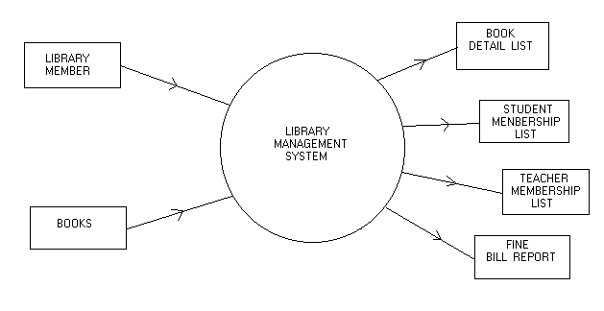

SID: 16103104

SID: 16103043